Things to do near Glenn H. Curtiss Museum
8419 State Route 54, Hammondsport, NY 14840-9795
8462 State Route 54, Hammondsport, NY 14840-9795
0.3 miles from Glenn H. Curtiss Museum
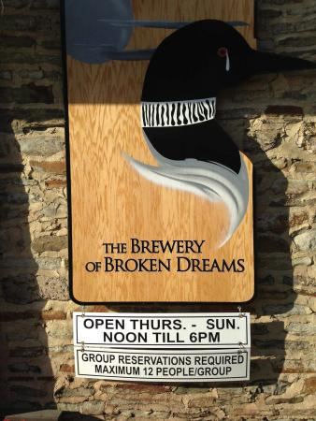
The Brewery of Broken Dreams
#12 of 35 things to do in Hammondsport
26 reviews
8319 Pleasant Valley Rd, Hammondsport, NY 14840-9549
0.8 miles from Glenn H. Curtiss Museum
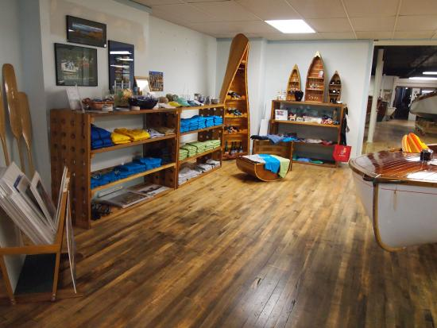
Finger Lakes Boating Museum
#6 of 35 things to do in Hammondsport
57 reviews
8231 Pleasant Valley Rd, Hammondsport, NY 14840
1.2 miles from Glenn H. Curtiss Museum
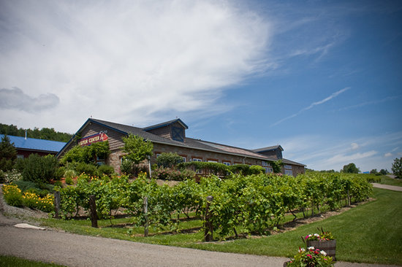
Bully Hill Vineyards Winery
#3 of 35 things to do in Hammondsport
362 reviews
8843 Greyton H Taylor Memorial Dr, Hammondsport, NY 14840-9637
2.5 miles from Glenn H. Curtiss Museum
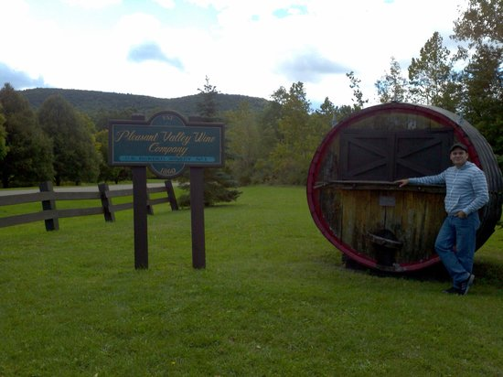
Pleasant Valley Wine Company
#9 of 35 things to do in Hammondsport
57 reviews
8260 Pleasant Valley Rd, Hammondsport, NY 14840-9514
1 miles from Glenn H. Curtiss Museum
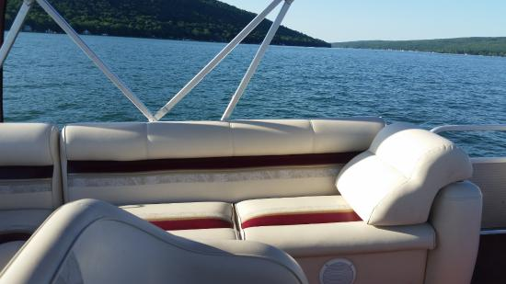
OnKeuka
#13 of 35 things to do in Hammondsport
19 reviews
57 Shethar St We pull up to the Depot Docks BEHIND the Train Depot Bldg, Hammondsport, NY 14840-9750
1.1 miles from Glenn H. Curtiss Museum
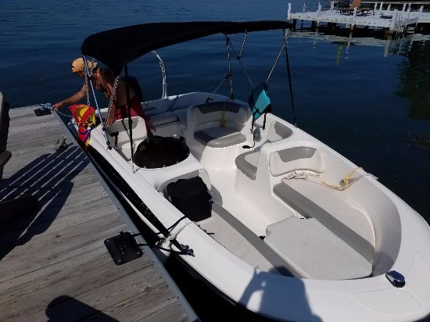
Keuka Boat Rentals
#3 of 4 Boat Tours & Water Sports in Hammondsport
1 review
South end of Keuka Lake, Hammondsport, NY
0.8 miles from Glenn H. Curtiss Museum
Opera House Antiques
#20 of 35 things to do in Hammondsport
5 reviews
61 - 63 Shethar St., Hammondsport, NY 14840
0.8 miles from Glenn H. Curtiss Museum
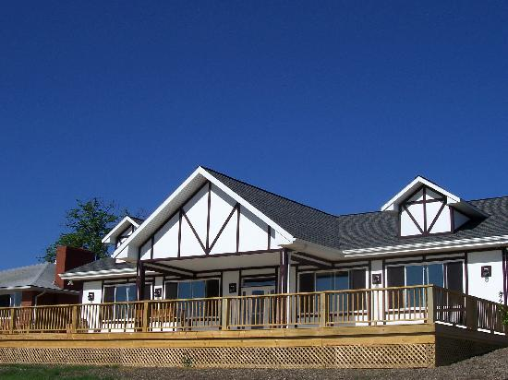
Dr. Konstantin Frank Winery
#2 of 35 things to do in Hammondsport
552 reviews
9749 Middle Rd, Hammondsport, NY 14840-9462
5.8 miles from Glenn H. Curtiss Museum
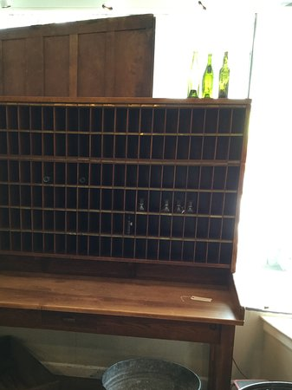
Shethar 57
#3 of 7 Shopping in Hammondsport
4 reviews
57 Shether St, Hammondsport, NY 14840-9379
0.9 miles from Glenn H. Curtiss Museum
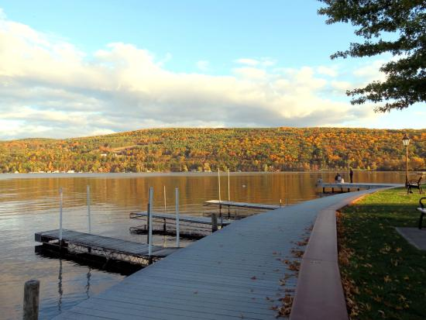
Depot Park
#18 of 35 things to do in Hammondsport
25 reviews
Water Street, Hammondsport, NY 14840
1.1 miles from Glenn H. Curtiss Museum
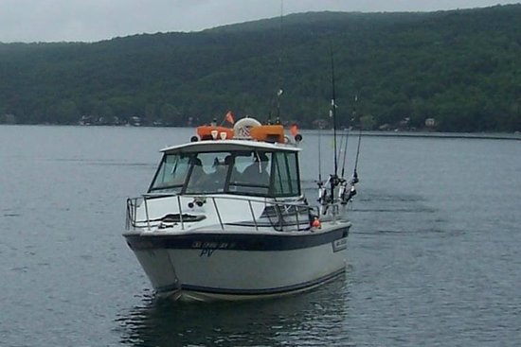
Keuka Big Foot Charters - Tours
#1 of 6 Tours in Hammondsport
14 reviews
1 Water St, Hammondsport, NY 14840-9750
1 miles from Glenn H. Curtiss Museum
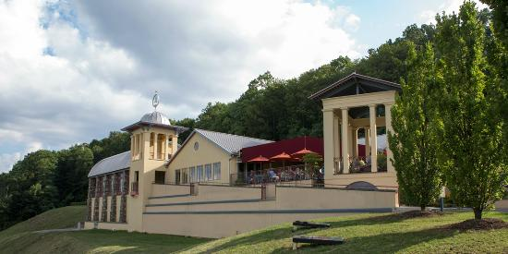
Heron Hill Winery
#4 of 35 things to do in Hammondsport
288 reviews
9301 County Route 76, Hammondsport, NY 14840-9685
3.9 miles from Glenn H. Curtiss Museum
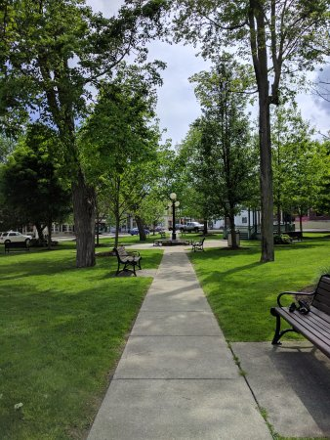
The Greater Hammondsport Area Chamber of Commerce and Visitor Center
#22 of 35 things to do in Hammondsport
3 reviews
47 Shethar St, Hammondsport, NY 14840-9380
0.9 miles from Glenn H. Curtiss Museum
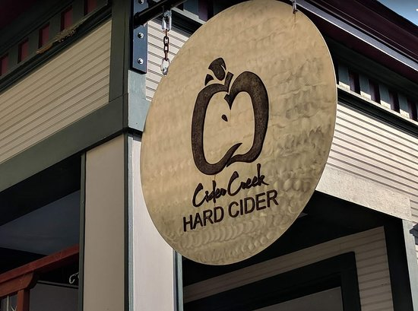
Cider Creek Hard Cider
#3 of 3 Nightlife in Hammondsport
2 reviews
49 Shethar St, Hammondsport, NY 14840-9379
0.9 miles from Glenn H. Curtiss Museum
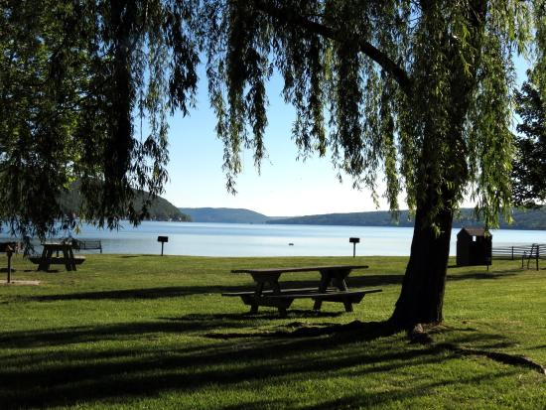
Champlin Beach Park
#21 of 35 things to do in Hammondsport
18 reviews
Ny-54, Hammondsport, NY 14840
0.9 miles from Glenn H. Curtiss Museum
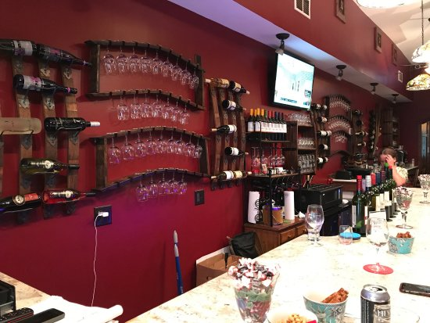
Over The Bridge Wine & Beer Bar
#1 of 3 Nightlife in Hammondsport
7 reviews
54 Pulteney St Ste B, Hammondsport, NY 14840-9593
1 miles from Glenn H. Curtiss Museum
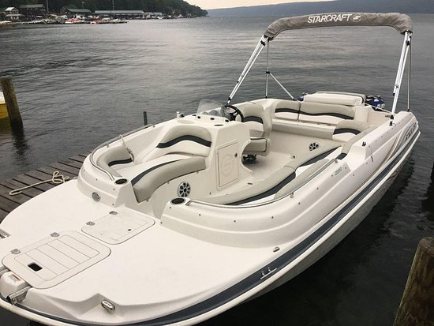
Keuka Watersports
#2 of 6 Tours in Hammondsport
16 reviews
8436 State Route 54, Hammondsport, NY 14840-9805
1.1 miles from Glenn H. Curtiss Museum
Maloney's Pub
#2 of 3 Nightlife in Hammondsport
3 reviews
57 Pulteney St Pultney and William, Hammondsport, NY 14840-9321
1 miles from Glenn H. Curtiss Museum
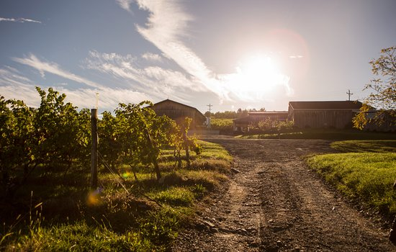
McGregor Vineyard
#2 of 11 things to do in Dundee
124 reviews
5503 Dutch St, Dundee, NY 14837-9746
9.6 miles from Glenn H. Curtiss Museum
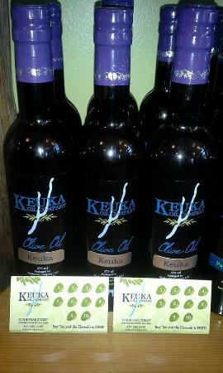
Keuka Oil Company
#5 of 7 Shopping in Hammondsport
2 reviews
27 Shether St, Hammondsport, NY 14840-9380
1.3 miles from Glenn H. Curtiss Museum
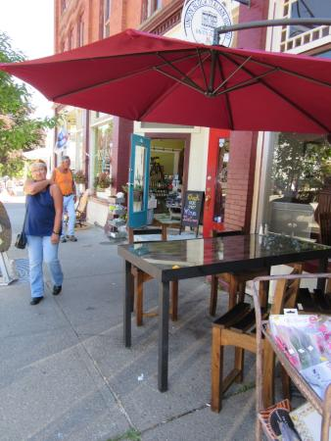
Keuka Lake Vineyards
#11 of 35 things to do in Hammondsport
50 reviews
8882 County Route 76, Hammondsport, NY 14840-9607
2.8 miles from Glenn H. Curtiss Museum
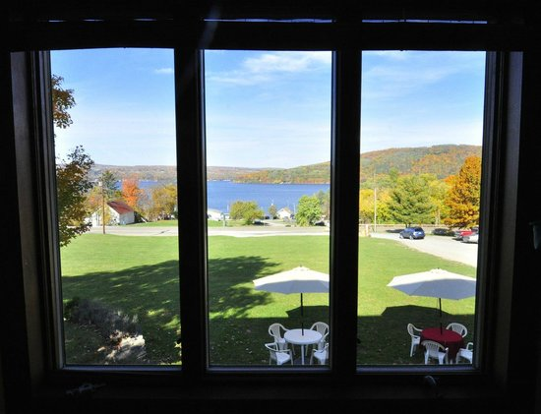
Ravines Wine Cellars
#5 of 35 things to do in Hammondsport
146 reviews
14630 State Route 54, Hammondsport, NY 14840-9363
8.6 miles from Glenn H. Curtiss Museum
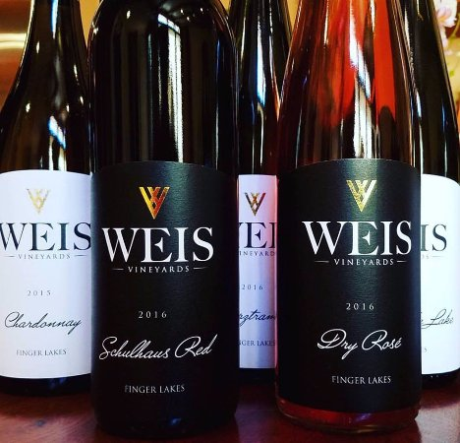
Weis Vineyards
#7 of 35 things to do in Hammondsport
31 reviews
10014 Day Rd, Hammondsport, NY 14840-9729
7.7 miles from Glenn H. Curtiss Museum
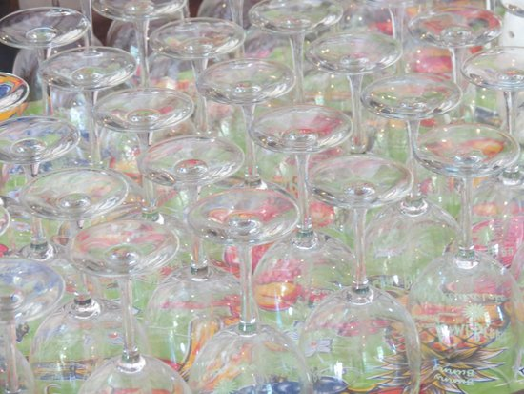
Lime Berry Winery
#8 of 35 things to do in Hammondsport
32 reviews
10014 Day Rd, Hammondsport, NY 14840-9729
7.7 miles from Glenn H. Curtiss Museum
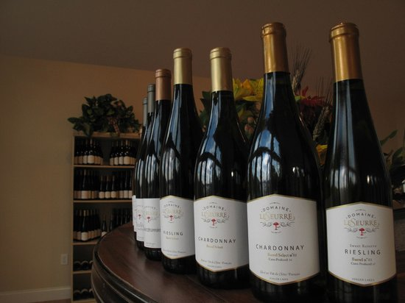
Domaine Leseurre Winery
#10 of 35 things to do in Hammondsport
56 reviews
13920 State Route 54, Hammondsport, NY 14840-9455
7.6 miles from Glenn H. Curtiss Museum
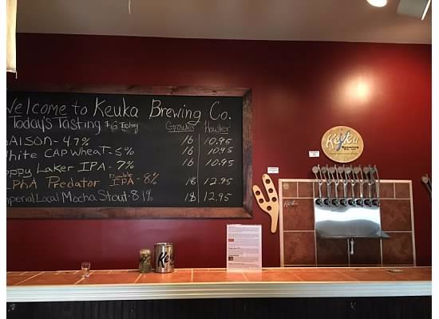
Keuka Brewing Company
#14 of 35 things to do in Hammondsport
41 reviews
8572 Briglin Rd, Hammondsport, NY 14840-9633
6.4 miles from Glenn H. Curtiss Museum
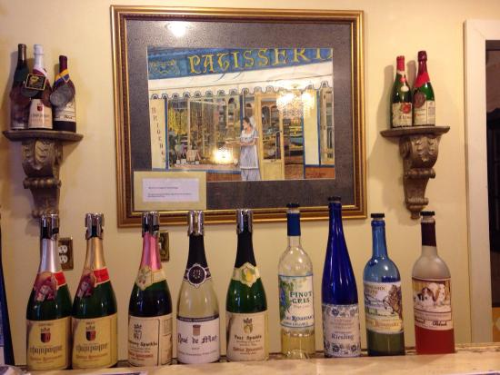
Chateau Renaissance Wine Cellars
#1 of 7 Shopping in Hammondsport
12 reviews
7494 Hatchery Road, Hammondsport, NY 14840
4.1 miles from Glenn H. Curtiss Museum
New York State Fish Hatchery
#9 of 12 things to do in Bath
1 review
7169 Fish Hatchery Rd, Bath, NY 14810-7923
3.2 miles from Glenn H. Curtiss Museum
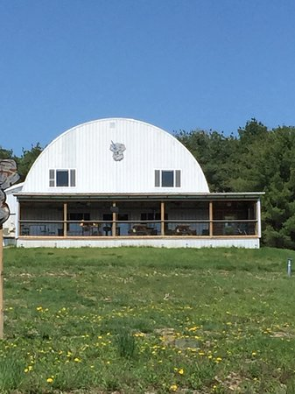
Krooked Tusker Distillery

